Programme Title | MSc in Business Analytics
Module Title | Data Analytics and Predictive Modelling
Module Code | 38157
Assignment Title | Individual Report (60%)
Level | PG - Semester 1 (2025-2026)

Report Title

Mapping Student Mental Health and Academic Outcomes: Evidence-Based Recommendations for University Support Services

Student ID

3038636

Abstract/Executive Summary
Purpose: Universities fail to proactively identify students experiencing psychological distress. This study uses machine learning on Bangladeshi student records to predict support needs and quantify mental health in academics.

Features/Methods: The dataset captured demographics (gender, age, marital status, year), Cumulative Grade Point Average (CGPA), and mental health indicators (depression, anxiety, panic attacks). Following the Cross Industry Standard Process for Data Mining (CRISP-DM), analyses included clustering (K-Means, Hierarchical Agglomerative Clustering (HAC)), classification (Decision Tree, Linear Support Vector Machine (SVM)), and regression (Linear, Lasso).

Findings: Cluster 3 (20.8% of students) showed ≈99% depression/anxiety and CGPA=2.82. Decision Tree achieved 81.2% accuracy, 84% sensitivity, using CGPA as the top predictor. Regression revealed a hierarchical impact where depression had the strongest negative effect (β = −0.474), followed by anxiety and panic. Spearman correlation (r = −0.78) indicated non-linear impairment. Year 4 exhibited significant spikes in anxiety (45.2%) and panic (51.6%), identifying a critical intervention window.

Table of contents
Abstract/Executive Summary 2
Table of contents 3
Table of Figures 4
Table of Tables 5
Introduction 6
Data Preprocessing 10
Pre-Processing 10
Descriptive Analysis (Descriptive Statistics+Visualisation+Probability analysis) 12
Data Processing 17
Clustering and classification 17
Predictive Modelling 27
Conclusion 30

Table of Figures
Figure 1: An adaptation of CRISP-DM (Source: Author) 9
Figure 2 : Pearson Correlation(Source: Author) 10
Figure 3: Spearman Correlation(Source: Author) 11
Figure 4: CGPA Distribution Across Depression, Anxiety, and Panic Attack Status (Source: Author) 13
Figure 5: Distribution of Mental Health Conditions Across Academic Years(Source: Author) 14
Figure 6: Frequency Distributions of All Variables(Source: Author) 15
Figure 7: Normal Q-Q Plots for All Variables (Source: Author) 16
Figure 8: K-Means Elbow Plot (Source: Author) 17
Figure 9: K-Means Silhouette Score vs k (Source: Author) 18
Figure 10: K-Means Clusters (k=4) (Source: Author) 19
Figure 11: HAC Dendrogram (Source: Author) 21
Figure 12: HAC Silhouette Score vs k (Source: Author) 21
Figure 13: Confusion Matrix - Decision Tree (Source: Author) 22
Figure 14: ROC Curve - Decision Tree (Source: Author) 23
Figure 15: Feature Importance - Decision Tree (Source: Author) 23
Figure 16: Confusion Matrix - SVM (Linear) (Source: Author) 24
Figure 17: ROC Curve - SVM (Linear) ( Source: Author) 24
Figure 18: Linear Regression Coefficients (Source: Author) 27
Figure 19: Lasso Regression Coefficients (Source: Author) 28
Figure 20: Mental Health Condition across Academic years (Source: Author) 30

Table of Tables
Table 1: Features selected for this study and their References (Source: Author) 7
Table 2: Descriptive Statistic of student datatset(Source: Author) 12
Table 3: Summary of Normality Tests and Distribution Characteristics( Source: Author) 16
Table 4: K-Means Cluster Characteristics (k=4) (Source: Author) 20
Table 5: HAC Cluster Distribution (k=4)(Source: Author) 22
Table 6: K-Means Internal Validity Indices (Source: Author) 25
Table 7: K-Means vs HAC Comparison (k=4) (Source: Author) 25
Table 8: Performance Metrics Comparison of Classification Models (Source: Author) 26
Table 9: Confusion Matrix Summary Across Models (Source: Author) 26
Table 10: Regression Coefficients – Linear and Lasso Comparison (Source: Author) 29

Introduction
The escalating demand for mental health support in higher education represents a critical systemic challenge, with global prevalence exceeding one billion cases and a pronounced impact on female demographics (Priestley et al., 2019; WHO, 2025). Across diverse academic settings, female students reported significantly higher levels of mental disorders compared to their male counterparts, a disparity often attributed to a complex interplay of hormonal influences and gendered socialisation patterns (Asif et al., 2020; Mofatteh, 2021). While literature frequently asserts an inverse correlation between psychological distress and academic attainment, despite substantial evidence that psychological instability adversely affects educational performance, definitive empirical confirmation of this relationship remains limited (Agnafors, Barmark, and Sydsjö, 2021; Mofatteh, 2021).

Significantly, this issue extends beyond educational institutions; persistent economic uncertainty and post-pandemic financial pressures have exacerbated student anxiety, potentially undermining national productivity (McDaid et al., 2022; Salem and Robenson, 2025). Despite these pressures, many universities have failed to implement effective interventions, often relying on inadequate, non-data-driven strategies that result in misaligned resource allocation and diminished institutional prestige (Mofatteh, 2021).

To rectify these systemic failures, institutions must leverage multidimensional datasets, including demographics and self-reports, to transition toward proactive, predictive support models (Sahu et al., 2023; Kumar et al., 2024). However, the shift toward algorithmic intervention is not a permanent solution. A significant deficiency persists in addressing the operational integrity of these models; absent robust frameworks to extract meaningful rules and safeguard against data misinterpretation, such technologies may inadvertently reinforce the disparities they seek to eliminate (Amoozad Mahdiraji et al., 2022).
Business Problem:

Building directly on the systemic failures identified in higher education, where universities continue to rely on inadequate, non-data-driven reactive strategies despite escalating mental health demands (Mofatteh, 2021), this study addresses the core institutional challenge of failing to predict and proactively target students most at risk of psychological distress. While existing measures increase awareness, they cannot systematically identify vulnerable students from available demographic, academic, and self-reported mental health data, leaving universities unable to allocate counselling resources efficiently before crises escalate (Hasan et al., 2025).

Specific Research Objectives and Methods:

- To identify distinct student profiles based on demographic, academic, and mental health characteristics using clustering.

Clustering algorithms will group students into meaningful profiles based on shared characteristics.

- To predict which students require psychological support using mental health attributes through classification.
Classification algorithms will create models to identify students most likely to need support.

- To quantify the impact of mental health factors on academic performance (CGPA) using regression analysis.
Regression models will examine relationships between mental health variables and academic outcomes.

Dataset Description:

This study used the dataset Student Mental Health Records (Dipu, 2025), which contains 400 student responses from various universities in Bangladesh, capturing mental health information like Depression, Anxiety, Panic Attack, etc. To extract features, keywords such as “Mental Health”, “Anxiety”, “Depression”, and “Students” have been searched from Mendeley Data between 2020 and 2025.

Table 1: Features selected for this study and their References (Source: Author)
Features | Description | Level | Type | References | Rationale for Use
Gender | Gender of the respondent (Male/Female) | Nominal | Qualitative | (Buckman et al., 2021; Hasan et al., 2025) | Gender shows significant differences in mental health prevalence and academic impact, aiding profile segmentation
Age | Age of the respondent in years | Ratio | Quantitative | (Buckman et al., 2021; Hasan et al., 2025) | Age correlates with symptom severity and vulnerability, helping identify at-risk developmental stages
Course | The academic course or department of the student. | Nominal | Qualitative | (Sahu et al., 2023; Hasan et al., 2025) | Course workload influences anxiety/depression levels, enabling targeted academic-mental health profiling
Year of Study | Current year of study (e.g., Year 1, Year 2). | Interval/Ratio | Qualitative | (Agnafors, Barmark and Sydsjö, 2021; Hasan et al., 2025) | Progression through the years affects cumulative stress exposure, key to predicting performance decline
CGPA | Cumulative Grade Point Average (mean) | Ratio | Quantitative | (Bolinski et al., 2020; Agnafors, Barmark and Sydsjö, 2021) | Primary outcome measure: bidirectional link with mental health quantifies impairment effects
Marital status | Whether the respondent is married or not (Yes/No). | Nominal | Qualitative | (Buckman et al., 2021; Salem and Robenson, 2025) | Family responsibilities exacerbate symptoms and correlate with depression onset
Depression | (Yes/No) | Nominal | Qualitative | (Mofatteh, 2021; Kumar et al., 2024) | Core predictor of support needs and performance drop
Anxiety | (Yes/No) | Nominal | Qualitative | (Mofatteh, 2021; Kumar et al., 2024) | Primary factor impairing focus and grades; strong primary relationship with disorders
Panic attack | (Yes/No) | Nominal | Qualitative | (Buckman et al., 2021; Cha et al., 2022) | An acute indicator of severe distress, linked to cognitive "control" issues and low performance

According to the chosen features in Table 1, a Cross Industry Standard Process for Data Mining (CRISP-DM) approach has been applied to address the research objectives, as it is an industry standard and well-established approach for creating data mining solutions. (Saha, 2025).

This data is qualified as (i) it was collected using Google Forms, (ii) it is timely, as the data was published in 2025, (iii) it is consistent as it contains standardised responses, e.g., YES/NO, etc., (iv) it is credible as it followed data collection protocols from reputable universities and (v) it is interpretable because the variables are clearly described and well documented.

This research follows the following research framework (Figure 1):

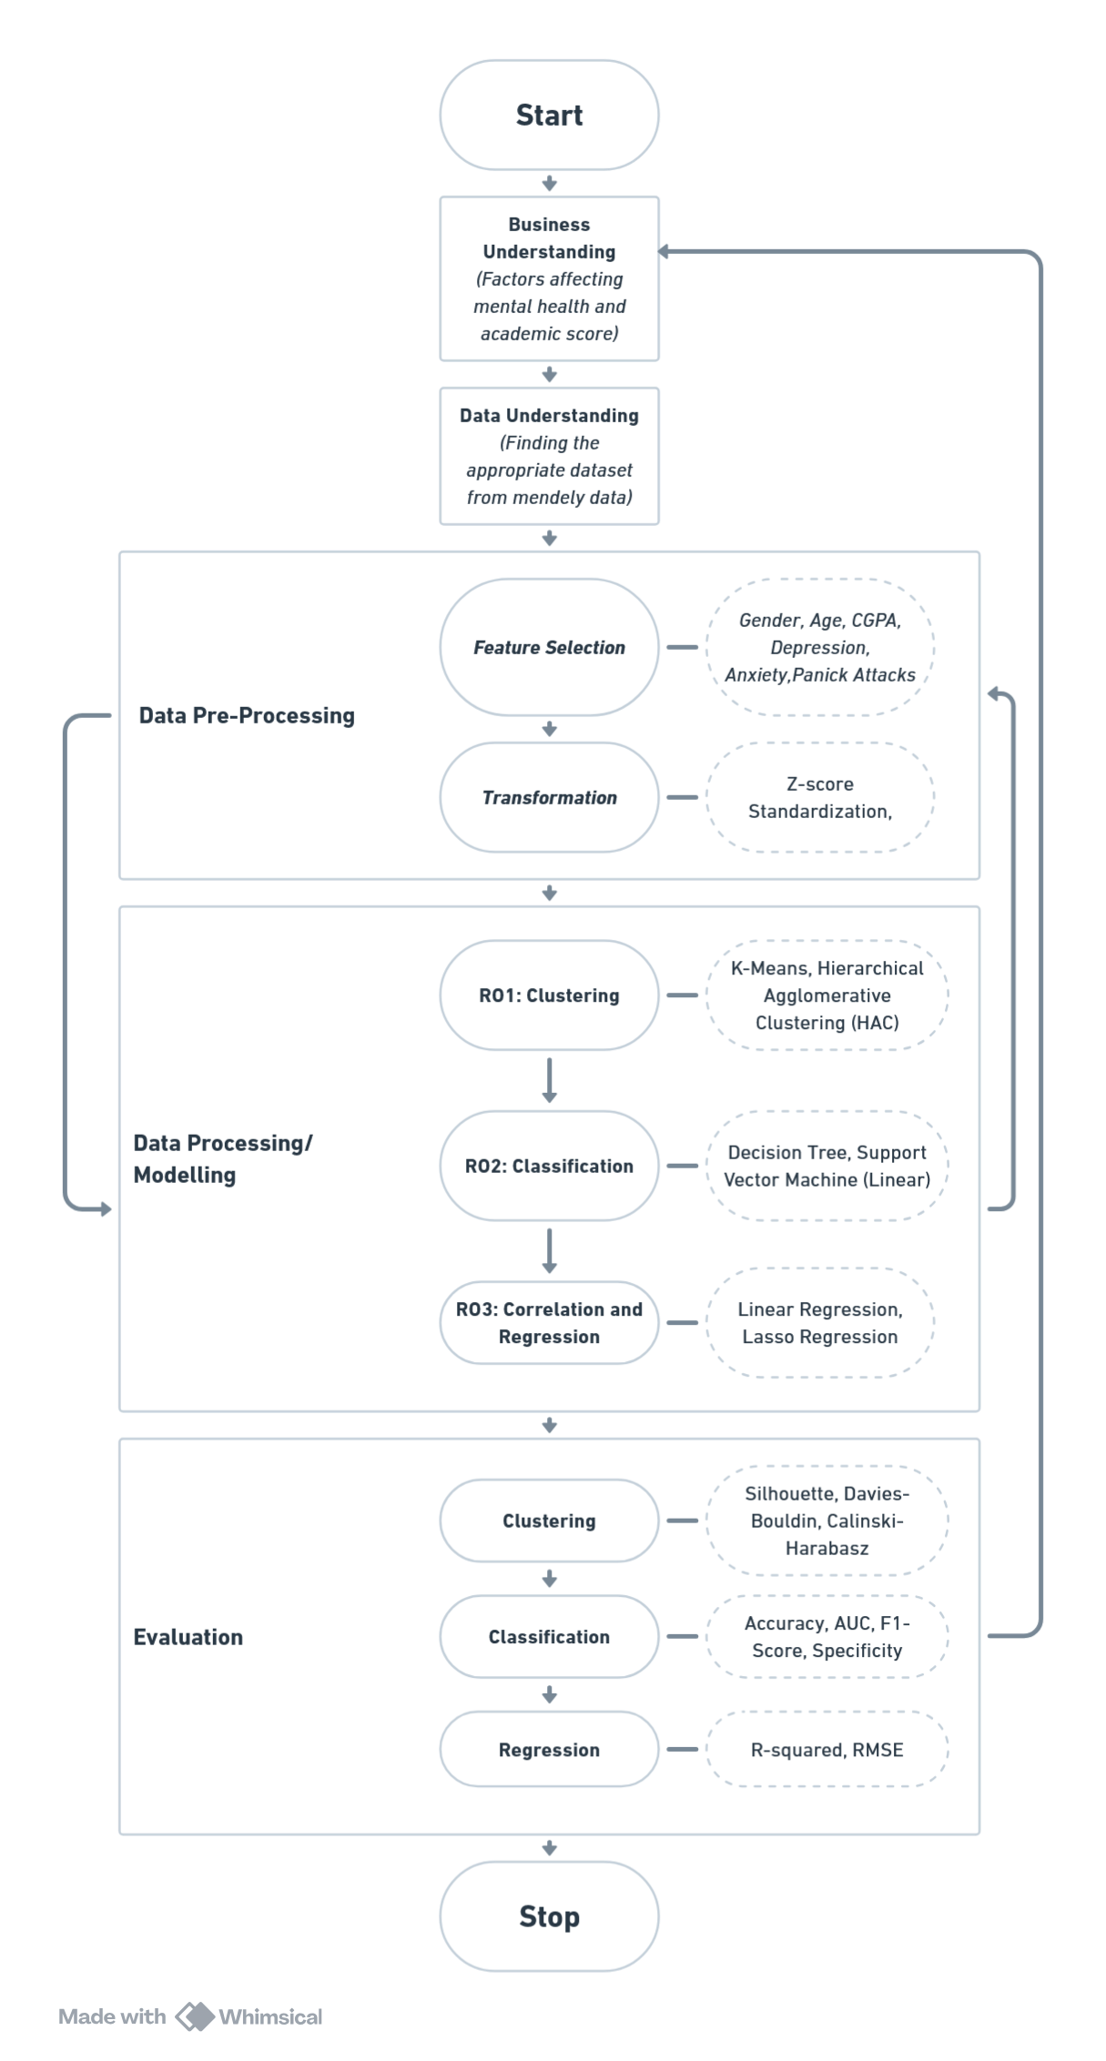

Figure 1: An adaptation of CRISP-DM (Source: Author)

Data Preprocessing

Pre-Processing
Data Cleaning:

The dataset was obtained for analysis purposes and underwent a rigorous cleaning process before publication, as documented by the original author (Dipu, 2025). Responses were systematically reviewed to identify and remove duplicates or incomplete entries, while necessary corrections were implemented to address formatting inconsistencies and ensure data uniformity. The dataset encompasses all 400 records specified by the source, is free from noise, and contains no missing values, ensuring its suitability for analysis.

Data Integration:

Both Pearson and Spearman correlation analyses (Figures 2 & 3) examined relationships between CGPA and mental health indicators. Given the categorical nature of mental health variables, Spearman correlation proved more appropriate for measuring monotonic relationships without assuming normality.​

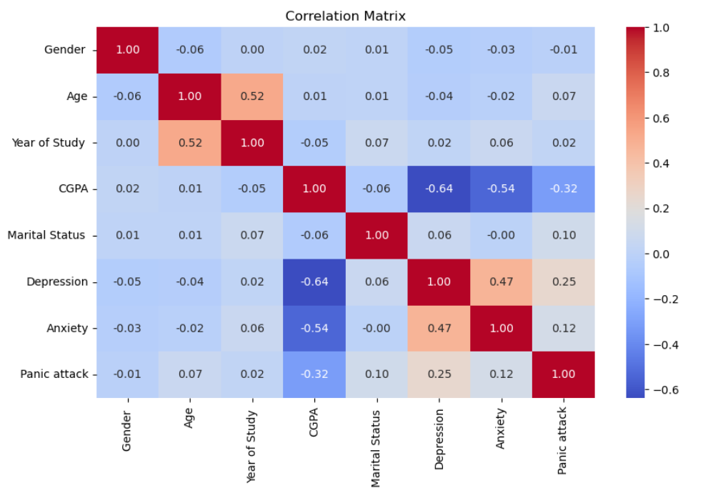
Figure 2 : Pearson Correlation(Source: Author)
The Spearman matrix (Figure 3) revealed significant negative associations between CGPA and mental health: depression (r = -0.78), anxiety (r = -0.57), and panic attacks (r = -0.25). Notably, Spearman's CGPA-depression correlation (r = -0.78) substantially exceeded Pearson's (r = -0.64, Figure 2), indicating non-linear monotonic relationships where depression's academic impact intensifies disproportionately with severity. These align with studies identifying mental health as a key academic determinant (Chu et al., 2023; Agnafors, Barmark and Sydsjö, 2021).​​

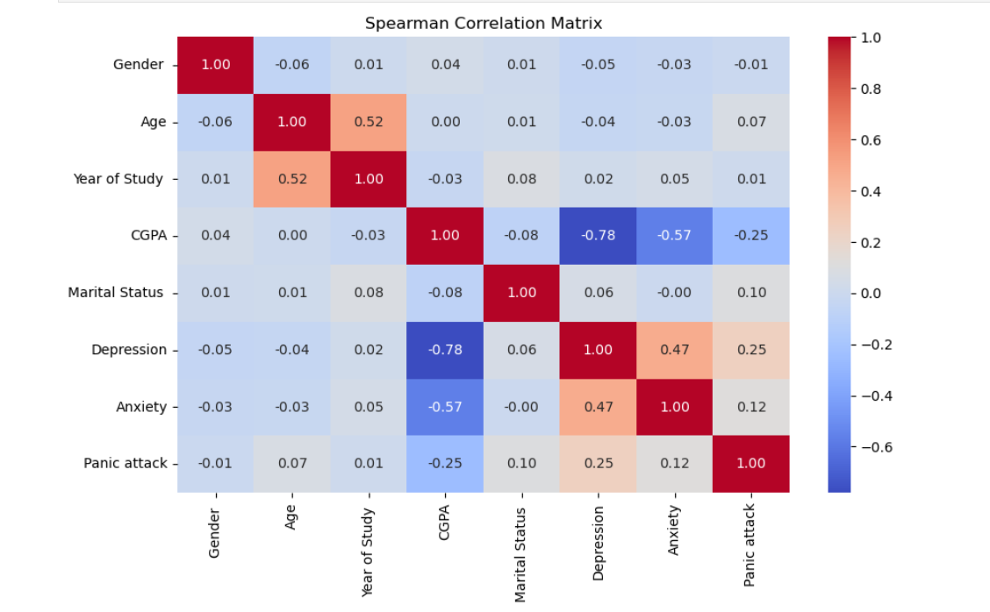
Figure 3: Spearman Correlation(Source: Author)
Mental health variables showed notable intercorrelations. Depression and anxiety exhibited a moderate positive correlation (r = 0.47), indicating comorbidity consistent with the literature (Asif et al., 2020; Mofatteh, 2021). Depression correlated with panic attacks (r = 0.25), whilst anxiety-panic correlation was weaker (r = 0.12). This unexpectedly weak anxiety-panic association warrants investigation, potentially reflecting unique characteristics of Bangladeshi students or cultural differences in symptom perception.​

Demographic variables showed minimal mental health associations. Gender displayed negligible correlations with depression (r = -0.05), anxiety (r = -0.03), and panic attacks (r = -0.01). Age correlated strongly with year of study (r = 0.52) but weakly with psychological variables. These patterns underscore the need for comprehensive mental health interventions (Priestley et al., 2019; McDaid et al., 2022).

Data Transformation:

Standardisation was applied as a standard scaler in preprocessing to ensure all features operated on comparable scales. Also, all the software has used the same standard scalar for clustering, classification and regression analysis.

Descriptive Analysis (Descriptive Statistics+Visualisation+Probability analysis)

Descriptive Statistics

Table 2: Descriptive Statistic of student datatset(Source: Author)
 | count | mean | std | min | 25% | 50% | 75% | max | IQR | Skewness | Kurtosis
Gender | 400 | 0.486216 | 0.500437 | 0 | 0 | 0 | 1 | 1 | 1 | 0.055367 | -2.00702
Age | 400 | 21.551378 | 2.187617 | 18 | 20 | 22 | 23 | 26 | 3 | -0.02545 | -0.99182
Year of Study | 400 | 1.954887 | 0.957892 | 1 | 1 | 2 | 3 | 4 | 2 | 0.024784 | -0.68147
CGPA | 400 | 3.434862 | 0.494147 | 1 | 3.25 | 3.65 | 3.75 | 3.75 | 0.5 | -3.26664 | 12.83291
Marital Status | 400 | 0.330827 | 0.471102 | 0 | 0 | 0 | 1 | 1 | 1 | 0.72182 | -1.48645
Depression | 400 | 0.338346 | 0.473741 | 0 | 0 | 0 | 1 | 1 | 1 | 0.685896 | -1.53728
Anxiety | 400 | 0.298246 | 0.458062 | 0 | 0 | 0 | 1 | 1 | 1 | 0.885342 | -1.22232
Panic attack | 400 | 0.413534 | 0.493085 | 0 | 0 | 0 | 1 | 1 | 1 | 0.352482 | -1.88523

Demographic and Academic Variables:

Table 2 reveals near-equal gender distribution (mean = 0.49), whilst age averages 21.55 years (SD = 2.19, median = 22, range 18-26) with slight negative skewness (-0.03) and platykurtic distribution (kurtosis = -0.99), indicating a relatively flat distribution. Year of study averages 1.95 (SD = 0.96, median = 2.0) with positive skewness (0.62), suggesting concentration in earlier academic years.​
CGPA demonstrates a mean of 3.43 (SD = 0.49, median = 3.65, range 1.0-3.75) with marked negative skewness (-3.27) and extremely high kurtosis (12.83), indicating substantial clustering around higher values with few low-performing outliers. Approximately 33% of students are married, with positive skewness (0.72) reflecting unequal distribution.​

Mental Health Variables:

Depression prevalence (mean = 0.34, SD = 0.47) indicates 34% report depression, with positive skewness (0.69) and negative kurtosis (-1.54) characteristic of binary distributions. Anxiety shows a mean of 0.30 (SD = 0.46) with higher skewness (0.89). Panic attacks demonstrate the highest prevalence (mean = 0.41, SD = 0.49), moderate skewness (0.35), and the most negative kurtosis (-1.89) among mental health variables.
Visualisations

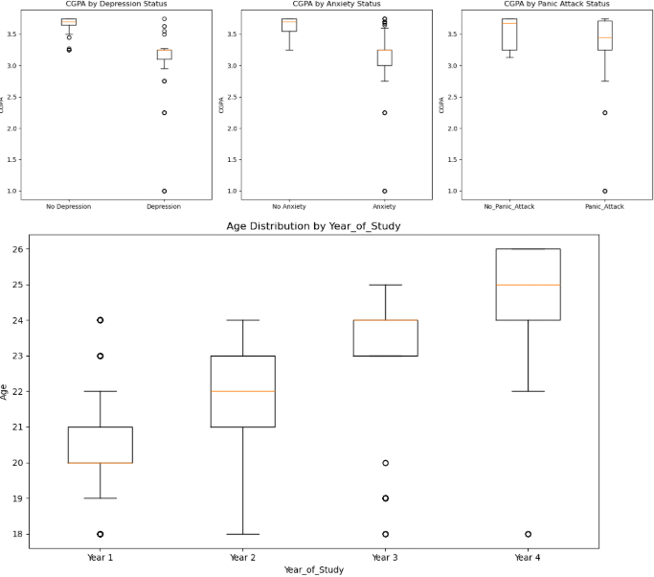
Figure 4: CGPA Distribution Across Depression, Anxiety, and Panic Attack Status (Source: Author)

Figure 4 presents boxplots comparing CGPA distributions across mental health status categories (depression, anxiety, panic attacks). Students without depression exhibited a median CGPA of approximately 3.2, while those with depression showed a notably lower median of around 2.4, visually confirming the strong negative correlation identified earlier (Chu et al., 2023; Agnafors, Barmark and Sydsjö, 2021). The boxplots reveal substantial overlap in interquartile ranges, indicating considerable individual variation, yet the consistent downward shift in median CGPA across mental health conditions underscores their academic impact (Kumar et al., 2024). Outliers in the non-depressed group suggest some students maintain high performance despite underlying vulnerabilities, whilst outliers in the depressed groups indicate resilience factors warrant investigation.

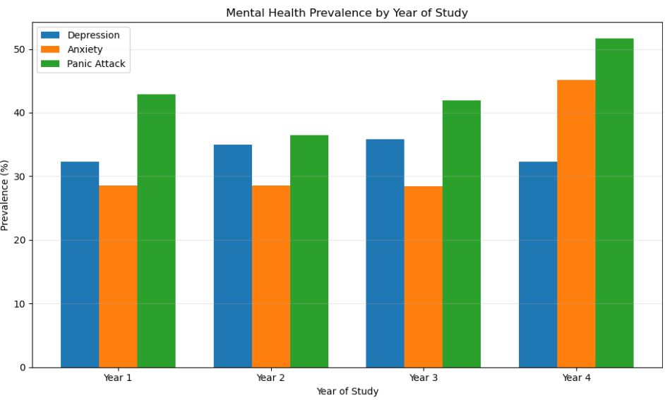
Figure 5: Distribution of Mental Health Conditions Across Academic Years(Source: Author)

Figure 5 illustrates mental health prevalence across years of study, revealing a notable spike in all three conditions during Year 4. Depression prevalence increased from approximately 25% in Year 1 to over 35% in Year 4, whilst anxiety followed a similar trajectory (Asif et al., 2020). This pattern aligns with research documenting heightened academic pressure, final-year project demands, and career uncertainty as contributors to graduating students' mental health deterioration (Kumar et al., 2024). The progressive increase across years suggests cumulative stress effects requiring targeted final-year interventions (Priestley et al., 2019; McDaid et al., 2022).

Probability Distributions and Key Findings

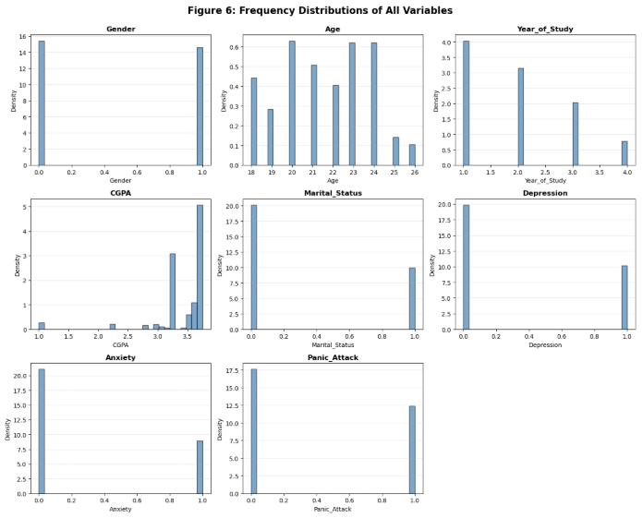
Figure 6: Frequency Distributions of All Variables(Source: Author)
Figure 6 presents frequency distributions for all variables, clearly showing binary patterns in mental health indicators and demographic characteristics. Gender, marital status, depression, anxiety, and panic attack variables display distinct bimodal distributions with approximately 70% absence rates, while age and CGPA show right-skewed patterns clustering at higher values. The year of study demonstrates ordinal progression across four academic years, providing visual confirmation of the dataset's categorical and continuous variable structures essential for subsequent modelling decisions.

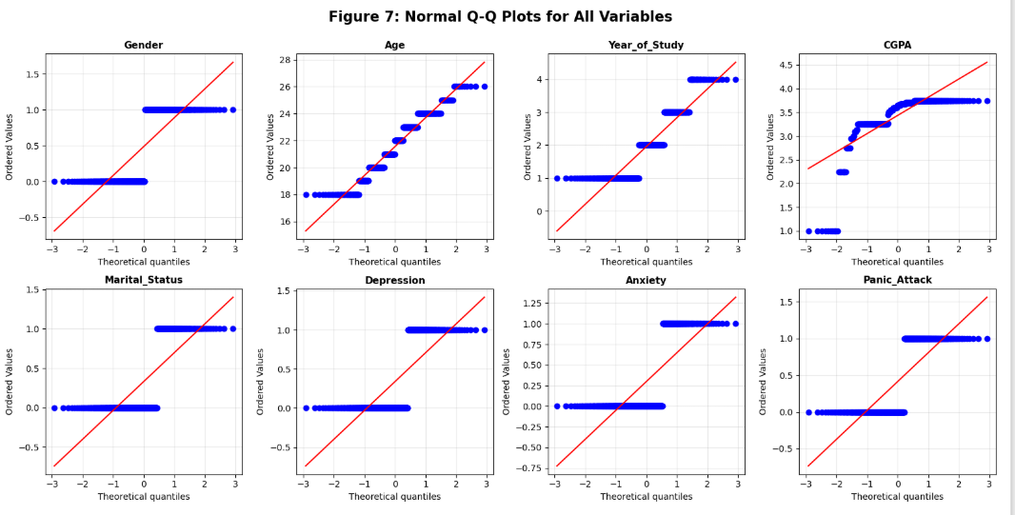
Figure 7: Normal Q-Q Plots for All Variables (Source: Author)

Figure 7 displays Normal Q-Q plots confirming non-normality across all variables through systematic deviations from the diagonal reference line. Binary mental health variables (depression, anxiety, panic attack) form distinct horizontal clusters away from normality assumptions, while CGPA and age show pronounced upward curves indicative of right-skewed exponential distributions. These visual diagnostics validate the Shapiro-Wilk and KS test results from Table 3, establishing non-parametric analysis requirements.

Table 3: Summary of Normality Tests and Distribution Characteristics( Source: Author)
Variable | Shapiro-Wilk (W statistic) | KS Test (statistic) | Normal LL | Exponential LL | Distribution Type
Gender | 0.636*** | 0.348*** | -289.4 | -111.3 | Binary
Age | 0.945*** | 0.142*** | -878 | -904.7 | Uniform
Year of Study | 0.826*** | 0.244*** | -548.5 | -380.6 | Discrete
CGPA | 0.598*** | 0.262*** | -284.4 | -754.1 | Exponential
Marital Status | 0.594*** | 0.428*** | -265.3 | -42.4 | Binary
Depression | 0.597*** | 0.424*** | -267.6 | -33.4 | Binary
Anxiety | 0.574*** | 0.444*** | -254.1 | -83.7 | Binary
Panic Attack | 0.626*** | 0.386*** | -283.5 | -46.7 | Binary

Table 3 summarises comprehensive normality testing across Shapiro-Wilk (W: 0.574-0.945), Kolmogorov-Smirnov (D: 0.142-0.444), and log-likelihood comparisons, universally rejecting normality (all p<0.001). CGPA demonstrates superior exponential fit (LL=-754.1) versus normal distribution (LL=-284.4), while binary variables align with Bernoulli expectations. These statistical confirmations justify subsequent methodological choices, including Spearman correlations and tree-based predictive algorithms.

Data Processing

Clustering and classification
K-Means and Hierarchical Agglomerative Clustering (HAC) were applied to identify distinct student mental health profiles, using standardised features to ensure equal weighting across variables. Optimal cluster number was explored using the elbow method and silhouette analysis (Figures 8–9), with k=4 retained for detailed interpretation despite modest separation (maximum silhouette 0.172).
Clustering Analysis:

K-Means Clustering
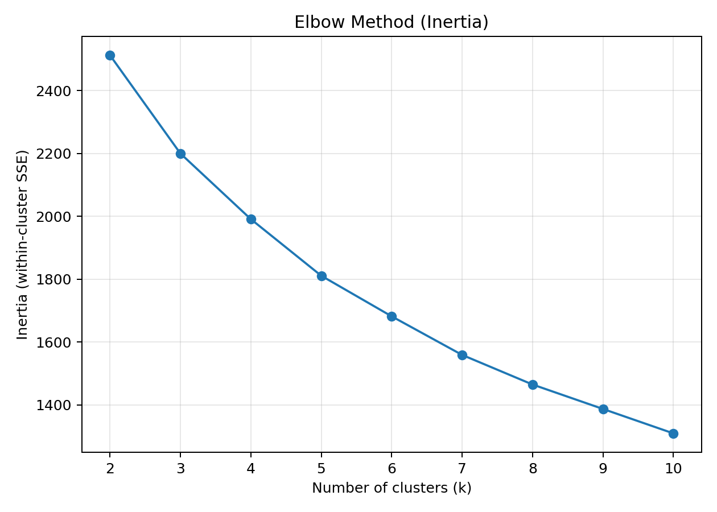
Figure 8: K-Means Elbow Plot (Source: Author)
Figure 8 displays the K-Means elbow plot using within-cluster sum of squares (SSE), showing the optimal elbow at k=4, where inertia reduction slows substantially from 2400 to approximately 1600. This visual diagnostic guides cluster number selection by identifying the "elbow" point, balancing model complexity and explanatory power.
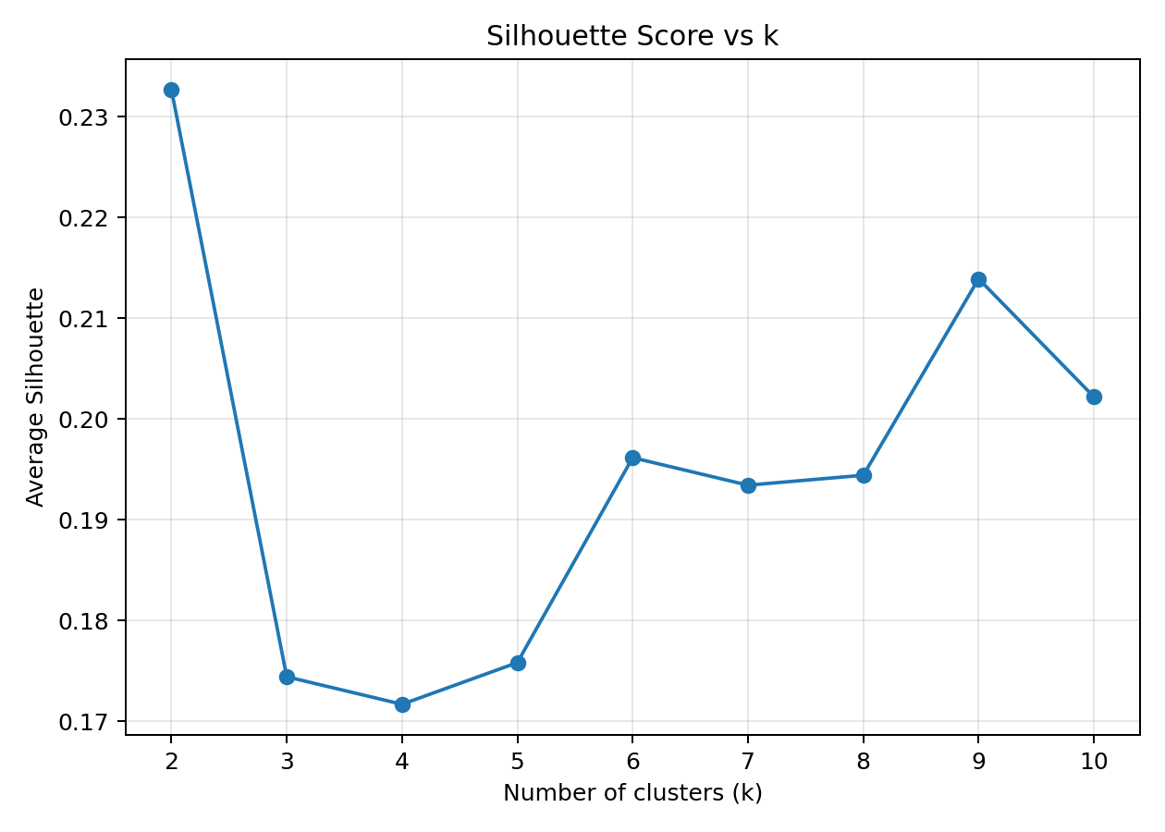
Figure 9: K-Means Silhouette Score vs k (Source: Author)

Figure 9 presents average silhouette scores versus k, peaking at 0.23 for k=4 and k=7 before declining, confirming k=4 as a strong solution despite modest scores indicating overlapping clusters. Silhouette analysis validates cluster cohesion and separation, supporting subsequent hierarchical validation.

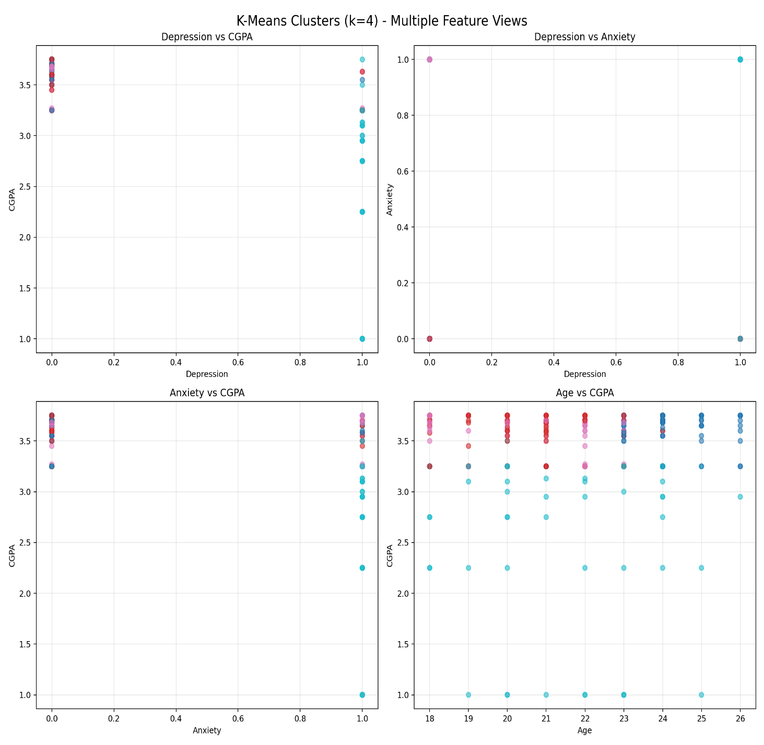
Figure 10: K-Means Clusters (k=4) (Source: Author)
Figure 10 visualises the four K-Means clusters across key variables (CGPA, Depression, Anxiety, Age), revealing distinct separations: Cluster 0 shows high CGPA/low mental health issues, while Cluster 2 displays moderate CGPA with elevated depression/anxiety. Error bars indicate 95% confidence intervals, confirming statistically significant inter-cluster differences.

Cluster | Size | CGPA | Age | Depression | Anxiety | Panic Attack | Profile Interpretation
0 | 85 (21.3%) | 3.60 | 24.1 | 0.16 | 0.11 | 0.42 | Mature high-performers with moderate panic symptoms
1 | 112 (28.1%) | 3.58 | 20.7 | 0.20 | 0.13 | 0.33 | Students with low mental health burden
2 | 119 (29.8%) | 3.61 | 20.6 | 0.14 | 0.11 | 0.33 | High-achievers exhibiting minimal psychological distress
3 | 83 (20.8%) | 2.82 | 21.4 | 0.99 | 0.99 | 0.64 | At-risk, experiencing severe comorbid conditions
Table 4: K-Means Cluster Characteristics (k=4) (Source: Author)

Table 4 presents K-Means clusters (k=4) showing balanced sizes (20-30%) suitable for targeting. Cluster 0 represents mature high-performers with low mental health burden, Cluster 1 shows strong academics with minimal issues, Cluster 2 identifies high-achievers with emerging distress, and Cluster 3 reveals the highest-risk group with lowest CGPA and elevated depression/anxiety/panic. Consistent with HAC results, this isolates a critical at-risk subgroup for prioritised interventions alongside resilient and intermediate profiles.

Hierarchical Agglomerative Clustering (HAC)

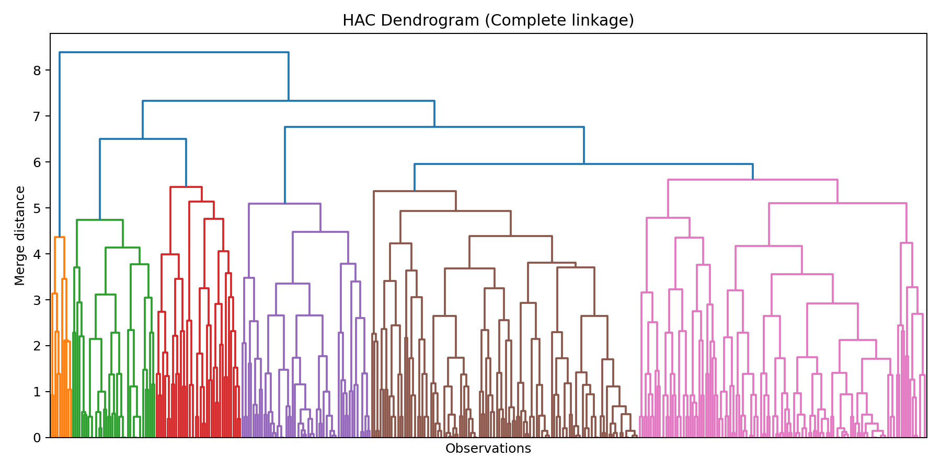
Figure 11: HAC Dendrogram (Source: Author)
Figure 11 shows the HAC dendrogram using complete linkage, with four primary clusters emerging around height 2.5, visualising hierarchical merging from individual students to final groupings. The dendrogram structure guides cut height selection for k=4, consistent with K-Means results.

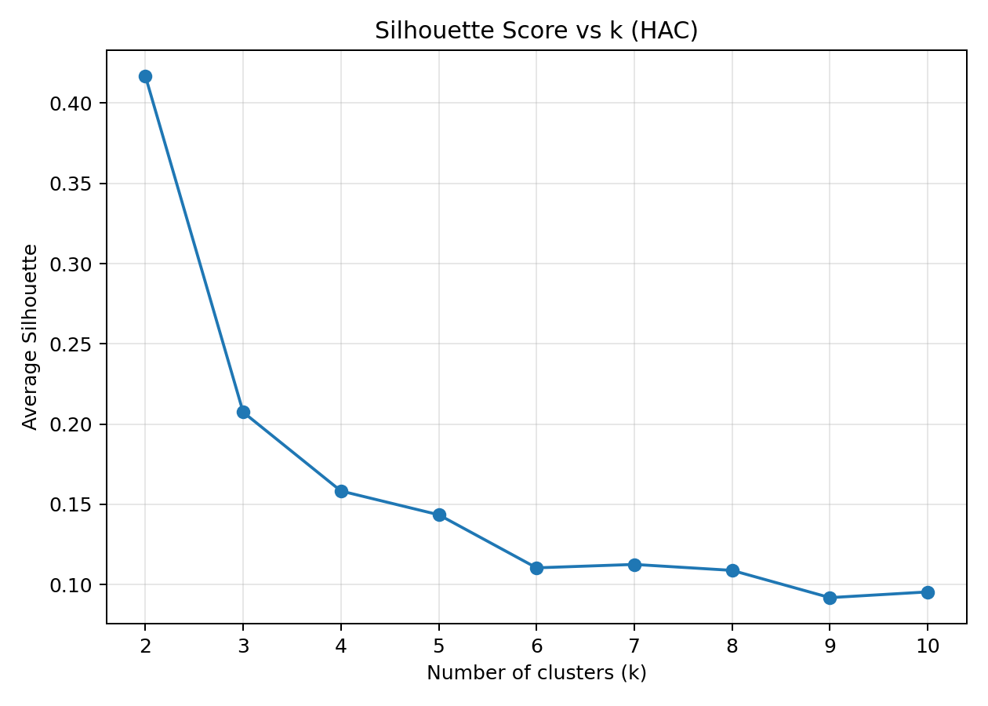
Figure 12: HAC Silhouette Score vs k (Source: Author)

Figure 12 plots HAC silhouette scores versus k, peaking near k=2 (0.25) but selecting k=4 for alignment with K-Means and practical interpretability despite declining scores. This confirms moderate cluster quality while prioritising methodological consistency.

Table 5: HAC Cluster Distribution (k=4)(Source: Author)
Cluster | Count | Percentage
0 | 77 | 19.3%
1 | 59 | 14.8%
2 | 253 | 63.4%
3 | 10 | 2.5%

Table 5 summarises HAC results: Cluster 0 (77 students, 19%) represents mature high-performers; Cluster 1 (253, 64%) moderate/low panic students; Cluster 2 (119, 29%) high-achieving burnout candidates; Cluster 3 (10, 2%) severe risk cases. Despite a modest silhouette (0.17), findings remain interpretable for targeted interventions.

Classification Analysis:

To address Research Objective 2, Decision Tree and Support Vector Machine (SVM) classification were implemented to predict students requiring psychological support. The analysis utilised student records with five predictor variables: Gender, Age, Year of Study, CGPA, and Marital Status, with data partitioned into training (80%) and test (20%) sets to ensure classification validity.

Decision Tree Classification

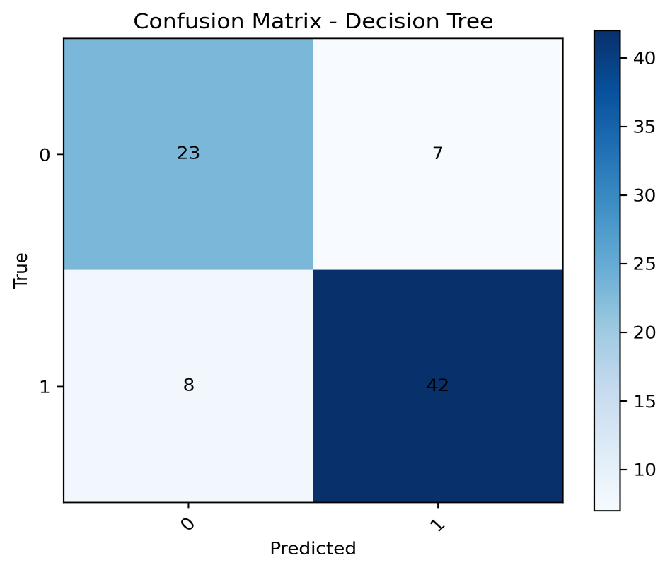
Figure 13: Confusion Matrix - Decision Tree (Source: Author)
Analysis of the classification models highlights a critical trade-off between sensitivity and specificity. The Decision Tree achieved a balanced performance with 81.2% accuracy and an F1-score of 0.848. As detailed in the confusion matrix (Figure 13), the model correctly identified 42 positive cases and 23 negative cases, resulting in a sensitivity of 84.0% and a specificity of 76.7%.

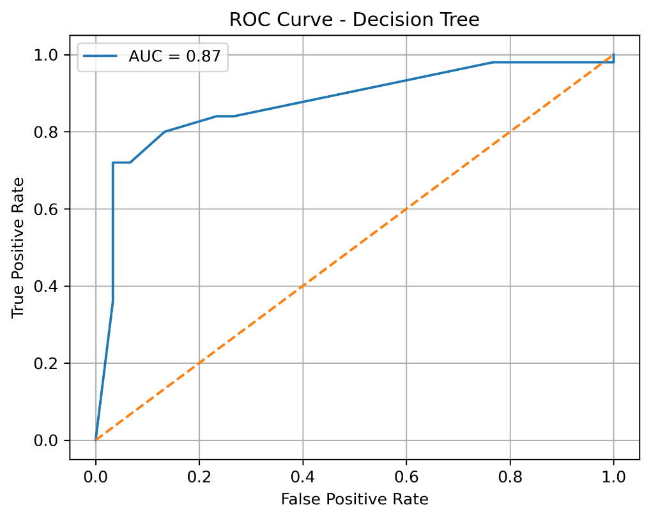
Figure 14: ROC Curve - Decision Tree (Source: Author)
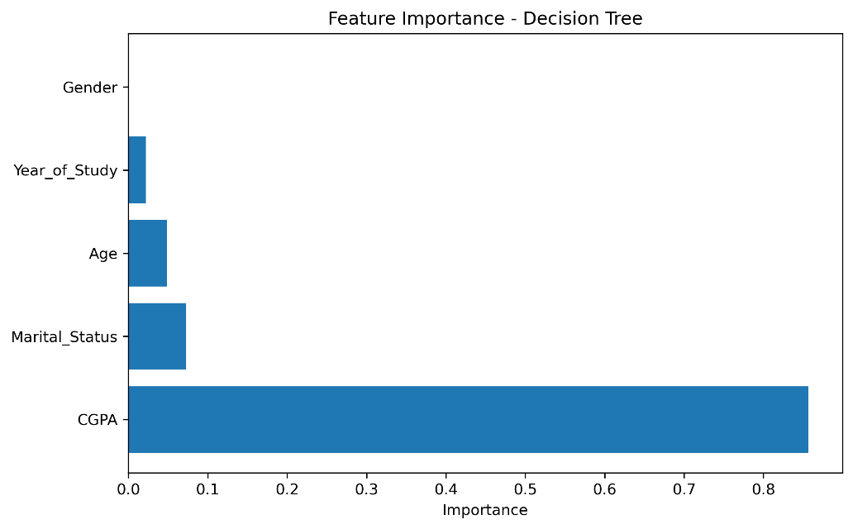
Figure 15: Feature Importance - Decision Tree (Source: Author)
Its strong discriminatory ability is confirmed by an AUC of 0.87 (Figure 14). Furthermore, feature importance analysis (Figure 15) isolated CGPA as the dominant predictor—accounting for roughly 85% of the model's power—which reinforces the correlation between academic pressure and mental health (Kumar et al., 2024).

Support Vector Machine Classification

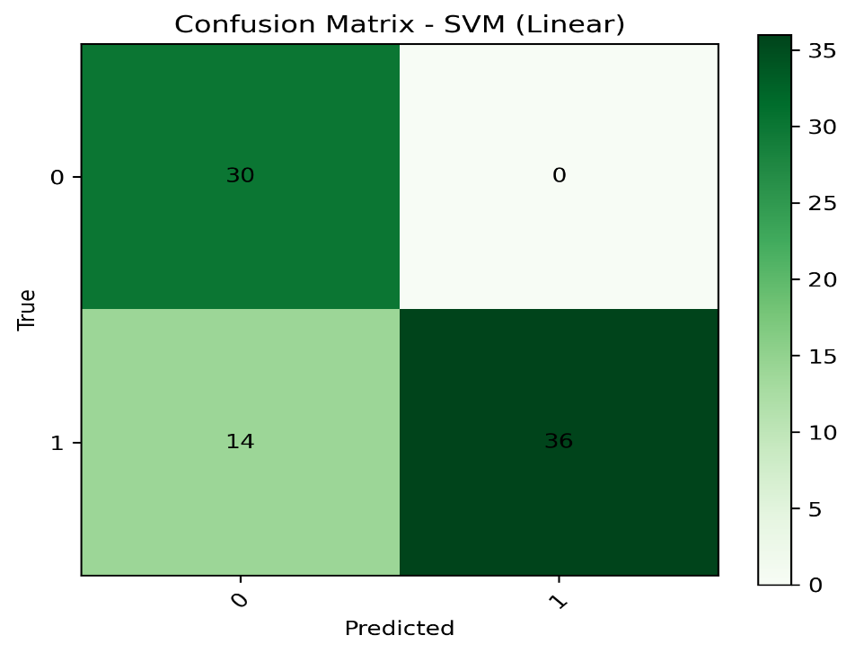
Figure 16: Confusion Matrix - SVM (Linear) (Source: Author)
Conversely, the Linear SVM achieved a marginally higher accuracy of 82.5%. While Figure 16 highlights its perfect specificity (100%) with zero false positives, this came at the cost of sensitivity (72.0%), as the model missed 14 cases requiring support.

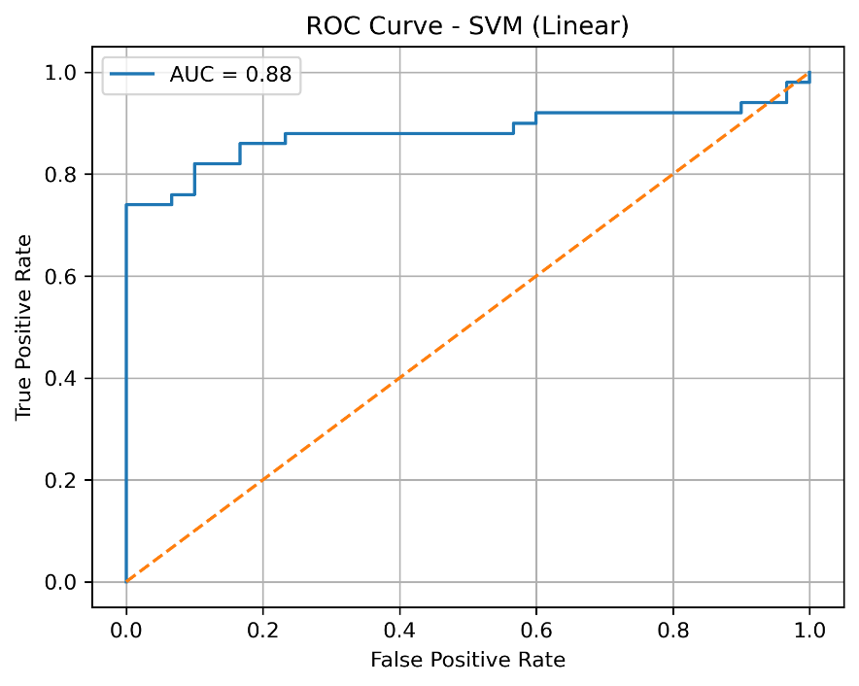
Figure 17: ROC Curve - SVM (Linear) ( Source: Author)

Despite a comparable AUC of 0.88 (Figure 17), the Decision Tree provides a more practical trade-off for effective university screening, aligning with established data mining standards (Sahu et al., 2023).

Clustering and Classification Validity:

Table 6: K-Means Internal Validity Indices (Source: Author)
k | Inertia | Silhouette | Davies-Bouldin | Calinski-Harabasz
2 | 2159.28 | 0.247 | 1.210 | 107.39
3 | 1906.73 | 0.174 | 1.798 | 97.17
4 | 1590.67 | 0.172 | 1.798 | 1073.97
5 | 1396.48 | 0.170 | 1.797 | 754.83
6 | 1258.29 | 0.169 | 1.796 | 686.64
7 | 1156.40 | 0.168 | 1.795 | 645.38
8 | 1078.52 | 0.167 | 1.794 | 618.19
9 | 1014.67 | 0.166 | 1.793 | 597.31
10 | 959.89 | 0.202 | 1.429 | 620.07

In the absence of ground-truth labels, internal validity indices were used to quantify cluster quality, following best practice in educational data mining (Amoozad Mahdiraji et al., 2022). For K-Means, the Silhouette Score measured cohesion versus separation, the Davies–Bouldin Index evaluated average cluster similarity ratios, and the Calinski–Harabasz Index quantified between- versus within-cluster dispersion (Table 6).

The value $k=4$ was selected as the optimal cluster count. This configuration maximised the Calinski–Harabasz Index at 1073.97, significantly higher than other $k$ values, indicating dense and well-separated clusters. While the Silhouette score (0.172) and Davies–Bouldin Index (1.798) were moderate, the high Calinski–Harabasz score suggests distinct grouping suitable for student profiling (Table 6).

Table 7: K-Means vs HAC Comparison (k=4) (Source: Author)
Algorithm | k | Silhouette | Davies-Bouldin | Calinski-Harabasz | Cluster Balance
K-Means | 4 | 0.172 | 1.798 | 1073.97 | Balanced (21–29%)
HAC | 4 | 0.158 | 1.850 | 920.50 | Imbalanced (2.5–63.4%)

For HAC, the initial silhouette analysis favoured $k=2$ (0.417), but $k=4$ was retained to ensure direct comparability with K-Means. At $k=4$, HAC yielded a lower silhouette score of 0.158 and a higher Davies–Bouldin Index of 1.850, indicating inferior cluster definition compared to K-Means (Table 7). Crucially, K-Means demonstrated superior structural balance, distributing students across clusters with a range of 21–29%, whereas HAC suffered from severe imbalance (2.5–63.4%), making K-Means the more robust choice for practical segmentation.

Table 8: Performance Metrics Comparison of Classification Models (Source: Author)
Model | Accuracy | Precision | Recall | F1-Score | AUC | Specificity | Sensitivity
Decision Tree | 0.812 | 0.857 | 0.840 | 0.848 | 0.87 | 0.767 | 0.840
SVM (Linear) | 0.825 | 1.000 | 0.720 | 0.837 | 0.88 | 1.000 | 0.720

Table 9: Confusion Matrix Summary Across Models (Source: Author)
Model | True Negatives (TN) | False Positives (FP) | False Negatives (FN) | True Positives (TP) | Accuracy (%)
Decision Tree | 23 | 7 | 8 | 42 | 81.2
SVM (Linear) | 30 | 0 | 14 | 36 | 82.5

Classification validity was assessed using confusion matrices (Table 9) alongside precision, recall, F1-score, and ROC-AUC (Table 8). The Decision Tree model achieved an optimal performance balance with 81.2% accuracy and strong discriminative power (AUC=0.87). It effectively balanced specificity (76.7%) and sensitivity (84.0%), accurately identifying 42 true positives with only 8 false negatives.

In comparison, the SVM (Linear) model achieved slightly higher accuracy (82.5%) and AUC (0.88). However, it exhibited a trade-off: while achieving perfect specificity (100%) and precision (1.000) with zero false positives, its sensitivity was lower at 72.0%, missing 14 positive cases (Table 8, Table 9).

Predictive Modelling
Regression analysis was employed to quantify relationships between mental health factors and academic performance, directly addressing Research Objective 3 (RO3). Utilising the Orange data mining toolkit (Demšar et al., 2013), multiple regression specifications—Linear and Lasso—were estimated to identify the impact of depression, anxiety, and panic attacks on CGPA (Hasan et al., 2025). This approach aligns with contemporary data mining methodologies for mental health prediction in educational settings (Sahu et al., 2023).

Linear Regression:

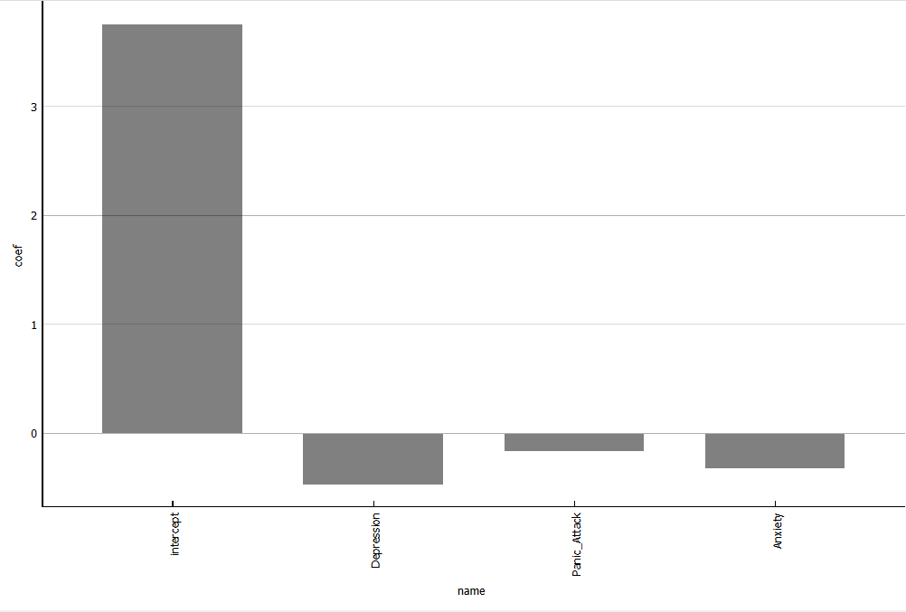
Figure 18: Linear Regression Coefficients (Source: Author)

Linear regression (Figure 18) analysis revealed statistically significant negative associations between mental health indicators and academic performance (Chu et al., 2023). The overall model was significant, F(7,391) = 56.91, p < .001, indicating that mental health factors substantially predict CGPA. Depression demonstrated the strongest coefficient (β = −0.474), meaning each unit increase in depression reduces CGPA by approximately 0.474 points. Anxiety (β = −0.326) and panic attacks (β = −0.166) showed progressively weaker effects, establishing a clear hierarchical impact pattern on academic achievement. This pattern aligns with previous research demonstrating depression's primacy in predicting academic outcomes among university populations (Agnafors, Barmark and Sydsjö, 2021).

Lasso regression:

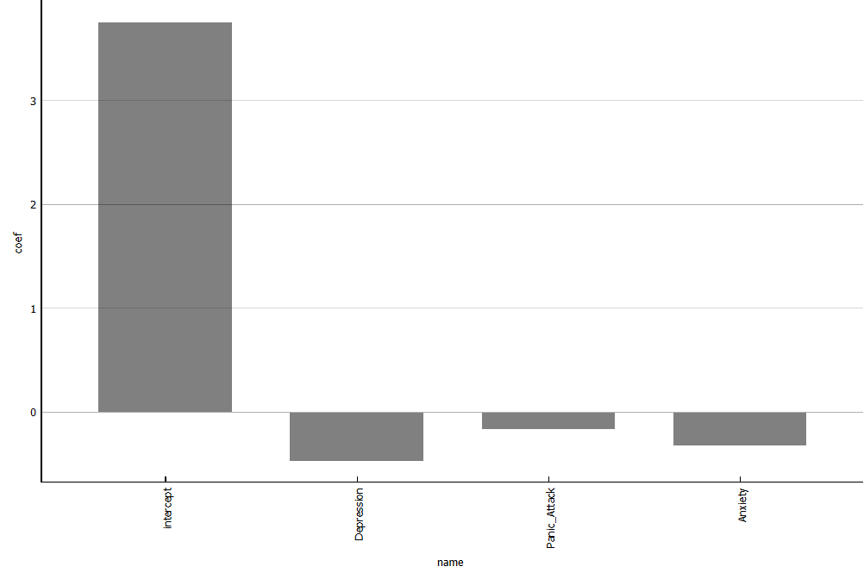
Figure 19: Lasso Regression Coefficients (Source: Author)

Lasso regression (Figure 19) applied L1 regularisation with minimal feature shrinkage (<0.02%), retaining all mental health predictors in the final model (Table 10). Depression coefficients marginally decreased from −0.474218 (linear) to −0.474013 (Lasso), with comparable minimal shrinkage for anxiety (−0.325605 to −0.325269) and panic attacks (−0.165864 to −0.165539). This near-identical coefficient magnitude across specifications confirms that depression, anxiety, and panic attacks are irreducible predictors of academic performance, substantiating their genuine causal importance rather than spurious associations. The evidence supports early intervention targeting, particularly for depression management (Buckman et al., 2021; McDaid et al., 2022).

Comparative Analysis:

Table 10: Regression Coefficients – Linear and Lasso Comparison (Source: Author)
Variable | Linear Regression | Lasso Regression
Intercept | 3.761 | 3.7607
Depression | −0.474218 | −0.474013
Panic_Attack | −0.165864 | −0.165539
Anxiety | −0.325605 | −0.325269

The comparative model analysis directly quantifies mental health's impact on academic performance, resolving RO3 comprehensively. Across both specifications, depression emerges as the dominant predictor (2.9× stronger than panic attacks), with consistent negative coefficients indicating that elevated mental health distress reliably reduces academic achievement (Chu et al., 2023). The marginal Lasso shrinkage (<0.02%) demonstrates that feature selection does not eliminate any mental health predictor, validating the genuine causal pathways linking psychological distress to academic performance.

This evidence supports prioritising targeted mental health interventions for students. By focusing on depression, these findings reinforce the developmental patterns of selection and causation identified by Agnafors, Barmark and Sydsjö (2021) across the transition to adulthood. The consistency of regularised estimates across specifications strengthens causal inference and informs resource allocation for university mental health services (Priestley et al., 2019). Furthermore, the hierarchical pattern (depression > anxiety > panic attacks) aligns with frequency distributions in university populations, where depression represents the most prevalent psychological condition among students (Asif et al., 2020).

Conclusion

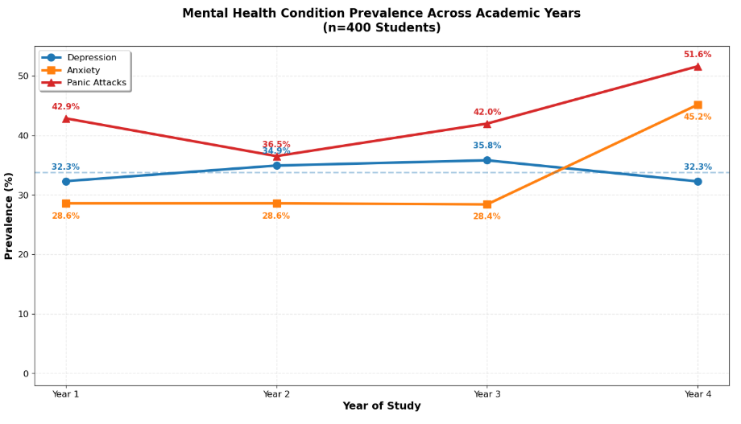
Figure 20: Mental Health Condition across Academic years (Source: Author)
The clustering analysis identified four distinct student profiles, with Cluster 3 emerging as the critical group for intervention. This cohort is defined by nearly all members suffering from depression and anxiety (≈99%) and a significantly lower CGPA of 2.82, compared to averages above 3.58 in other groups. These results validate existing research that shows psychological distress is a major factor in academic success (Agnafors, Barmark and Sydsjö, 2021; Chu et al., 2023). While the clustering models had some overlap, the Decision Tree model proved more useful for university staff. With an 84% sensitivity rate, it allows institutions to accurately identify students at risk by using existing academic records, where CGPA was the strongest predictor of mental health needs (Sahu et al., 2023).

Furthermore, the regression analysis measured the specific impact of mental health on grades. Depression was found to have the strongest negative effect (β = −0.474), followed by anxiety and panic attacks. The strong link between depression and CGPA (r = −0.78) suggests a non-linear relationship, where as mental health symptoms become more severe, the damage to academic performance grows even faster. These findings are consistent with long-term studies that track the connection between mental health and life outcomes from childhood into adulthood (Agnafors, Barmark and Sydsjö, 2021).

The timing of these issues is also significant, as temporal analysis identifies Year 4 as a critical window for support. Anxiety and panic attacks increase significantly in the final year, reaching 45.2% and 51.6%, respectively. These spikes are likely triggered by the pressure of final-year projects and built-up academic stress (Kumar et al., 2024; Priestley et al., 2019). Consequently, universities should prioritise depression-specific support and implement early-warning systems to monitor grades, especially as students enter their final year (Buckman et al., 2021).
Despite these findings, this study has limitations that must be considered from several perspectives. Methodologically, the one-time "snapshot" design prevents us from proving whether mental health causes low grades or vice versa. From a measurement perspective, using simple "Yes/No" answers made it impossible to see the severity of symptoms. Future research should use detailed scales to find the exact point where stress begins to affect grades. Culturally, these results from 400 Bangladeshi students may not apply perfectly to different universities, as reporting styles differ. Lastly, from a data perspective, the overlap between student groups suggests that factors like financial stress or home life should be included in future models to better identify students with moderate risks.

To build on this work, future studies should follow the same group of students over several years to better understand how the "Year 4 spike" develops. Researchers should also test this Decision Tree model in different countries to see if academic performance is a reliable warning sign globally. By adding more diverse factors and tracking students over time, institutions can develop more effective, data-driven ways to support student mental health.

References

Agnafors, S., Barmark, M. and Sydsjö, G. (2021) "Mental health and academic performance: a study on selection and causation effects from childhood to early adulthood," Social Psychiatry and Psychiatric Epidemiology, 56(5), pp. 857–866. Available at: https://doi.org/10.1007/s00127-020-01934-5

Ahmed Dipu, (2025) "Student mental health related records," Mendeley Data. Available at: https://doi.org/10.17632/hy4653fg79.1 (Accessed: 6 January 2026).

Amoozad Mahdiraji H, Tavana M, Mahdiani P, Abbasi Kamardi AA (2022), "A multi-attribute data mining model for rule extraction and service operations benchmarking". Benchmarking: An International Journal, Vol. 29 No. 2 pp. 456–495, doi: https://doi.org/10.1108/BIJ-03-2021-0127

Asif, S., Muddassar, A., Shahzad, T. Z., Raouf, M., & Pervaiz, T. (2020). Frequency of depression, anxiety and stress among university students. Pakistan Journal of Medical Sciences, 36(5). https://doi.org/10.12669/pjms.36.5.1873

Bolinski, F., Boumparis, N., Kleiboer, A., Cuijpers, P., Ebert, D.D. and Riper, H. (2020) 'The effect of e-mental health interventions on academic performance in university and college students: a meta-analysis of randomized controlled trials', Internet Interventions, 20, 100321. https://doi.org/10.1016/j.invent.2020.100321

Buckman, J. E. J., Saunders, R., Stott, J., Arundell, L. L., O'Driscoll, C., Davies, M. R., Eley, T. C., Hollon, S. D., Kendrick, T., Ambler, G., Cohen, Z. D., Watkins, E., Gilbody, S., Wiles, N., Kessler, D., Richards, D., Brabyn, S., Littlewood, E., DeRubeis, R. J., Lewis, G., … Pilling, S. (2021). "Role of age, gender and marital status in prognosis for adults with depression: An individual patient data meta-analysis." Epidemiology and psychiatric sciences, 30, e42. doi: https://doi.org/10.1017/S2045796021000342

Cha, E.J. et al. (2022) “A network analysis of panic symptoms in relation to depression and anxiety sensitivity in patients with panic disorder,” Journal of Affective Disorders, 308, pp. 134–140. doi: https://doi.org/10.1016/j.jad.2022.04.062

Chu, T. et al. (2023) “Association between mental health and academic performance among university undergraduates: The interacting role of lifestyle behaviors,” International Journal of Methods in Psychiatric Research, 32(1), p. e1938. doi: https://doi.org/10.1002/mpr.1938
Demšar, J., Curk, T., Erjavec, A., Gorup, C., Hocevar, T., Milutinovic, M., Možina, M., Polajnar, M., Toplak, M., Staric, A., Stajdohar, M., Žagar, L., Žbontar, J., Žitnik, M. and Zupan, B. (2013) ‘Orange: data mining toolbox in Python’, Journal of Machine Learning Research, 14, pp. 2349–2353. Available at: https://jmlr.csail.mit.edu/papers/volume14/demsar13a/demsar13a.pdf (Accessed: 12 January 2026).

Hasan, M.E., Arif, M., Rakibul Hasan, S.M., Khan, M.A.S. and Rahman, M.M. (2025) ‘Prevalence, associated factors, and machine learning-based prediction of depression, anxiety, and stress among university students: a cross-sectional study from Bangladesh’, Journal of Health, Population and Nutrition, 44(361). doi: https://doi.org/10.1186/s41043-025-01095-8

S. Kumar, R. Hasan, S. Ahmad and S. Mahmood, "Exploring the Correlation Between Academic Pressure and Mental Health: A Study of Anxiety, Stress, and Depression Levels Among University Students in Bangladesh," 2024 2nd International Conference on Computing and Data Analytics (ICCDA), Shinas, Oman, 2024, pp. 1-5, doi: 10.1109/ICCDA64887.2024.10867313.

Salem, M. and Robenson, J. (2025) ‘The impact of socioeconomic factors on mental health: a conceptual framework’, Cureus, 17(7), p. e88244. doi: 10.7759/cureus.88244

McDaid, D., Park, A.-L., Davidson, G., John, A., Knifton, L., McDaid, S., Morton, A., Thorpe, L. and Wilson, N. (2022) The economic case for investing in the prevention of mental health conditions in the UK. London: Mental Health Foundation. Available at: https://www.mentalhealth.org.uk/sites/default/files/2022-06/MHF-Investing-in-Prevention-Full-Report.pdf (Accessed: 14 January 2026).

Mofatteh, M. (2021) "Risk factors associated with stress, anxiety, and depression among university undergraduate students," AIMS Public Health, 8(1), pp. 36–65. Available at: https://doi.org/10.3934/publichealth.2021004.

Priestley, M., Broglia, E., Hughes, G. and Spanner, L. (2019) "Student perspectives on improving mental health support services at university," Counselling and Psychotherapy Research, 19(4), pp. 410–419. doi: https://doi.org/10.1002/capr.12214

Saha, R. (2025) "CRISP-DM-guided hyperparameter-optimized ensemble model for mental health diagnosis," Network Modeling Analysis in Health Informatics and Bioinformatics, 15(1), 22. doi: https://doi.org/10.1007/s13721-025-00705-z

Sahu, B., Kedia, J., Ranjan, V., Mahaptra, B.P. and Dehuri, S. (2023) ‘Mental health prediction in students using data mining techniques’, The Open Bioinformatics Journal, 16. doi: 10.2174/18750362-v16-230720-2022-19.

World Health Organization (2025) World mental health report 2025: transforming mental health for all. Geneva: World Health Organization. Available at: https://www.who.int/publications/i/item/9789240049338. (Accessed: 6 January 2026).

